 | BAHRIA UNIVERSITY, (Karachi Campus)  Department of Software Engineering  Assignment 3 – Spring- 2023

COURSE TITLE: Linear Algebra COURSE CODE: Gsc-121
Class: BSE (2A, 2B, 2C) Morning
Course Instructor: Muhammad imran afridi Time Allowed: 3 Days
Submission Date: 3 June 2023. Max. Marks: 5 Marks

Assignment No. 03, (CL02) [5 Marks]

Q1:- Evaluate the system of equations by crammer’s Rule

Q2:- Determine the values of ‘a’ such that 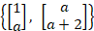 are linearly
Independent.

Q3:- (a) Evaluate the bases for Null A and Col A. Also list the rank A and Dimension of Null A.
Where
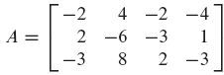
Q4:- The set is a basis for find the coordinate vector of

